Strategic Decision-Making using Power BI

Pre-Report Submission

Submitted to- Dr. ARPIT YADAV

Name: BISHAL KUMAR SHAW

Reg. No.: 2023JULB01220

Table Of Content

* Problem Statement ……………………………………………………………1
* Data Requirement ……………………………………………………………..2
* Data Collection …………………………………………………………………3
* Data Validation ………………………………………………………………….4
* Data Cleaning ……………………………………………………………………5
* Tools ………………………………………………………………………………..6
* Dashboard ………………………………………………………………………..7
* Storytelling ………………………………………………………………………..8

**1. PROBLEM STATEMENT**

This interactive dashboard presents a comprehensive analysis of sales data from 2014 to 2017. It includes key performance indicators (KPIs) such as total sales, profit margins, and year-over-year growth. Users can filter data by region, product category, and sales channels, providing dynamic insights into trends and performance.

**Key Features:**

**Sales Trends:** Visualized using line charts to show monthly and yearly sales progression.

**Regional Analysis:** Heatmaps and bar charts representing sales performance across various regions.

**Product Breakdown:** Category-wise analysis showing top-performing products and their contribution to overall sales.

**Profit and Loss Analysis:** Detailed metrics on profits and losses for different sales channels.

**Interactive Filters:** Users can drill down into specific time frames, regions, and product categories for deeper insights. The dashboard allows stakeholders to make data-driven decisions, optimize sales strategies, and forecast future trends.

**Objective**

The objective of this dashboard is to provide a comprehensive sales report analysis, enabling stakeholders to monitor and evaluate key metrics and trends across various dimensions. Here's a breakdown of its purpose:

1. **Revenue and Profit Monitoring**:
   * Displays total revenue and profit metrics for an overarching view of business performance.
2. **Category-Level Insights**:
   * Breaks down revenue by product categories (e.g., Special vs. General) to understand the contribution of each category.
3. **Subcategory Analysis**:
   * Further segmentation of revenue within subcategories (e.g., Extra, Super, Micro, Regular) to identify top-performing segments.
4. **Product Performance**:
   * Revenue trends for individual products and subcategories to assess product-specific contributions.
5. **Temporal Trends**:
   * Tracks revenue growth by year, quarter, and month for a time-based performance analysis.
6. **Profitability Analysis**:
   * Examines gross profit and month-over-month (MoM) growth trends to understand profitability dynamics over time.
7. **Quarterly Trends**:
   * Analysis quarter-over-quarter (QoQ) growth in revenue, highlighting periods of high and low performance.
8. **Interactive Filtering**:
   * Allows users to filter data by country, year, month, and quarter to focus on specific periods or markets.

The dashboard is designed to assist decision-makers in identifying growth opportunities, monitoring financial health, and strategizing based on performance trends.

**2. DATA REQUIREMENT**

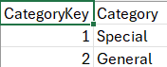

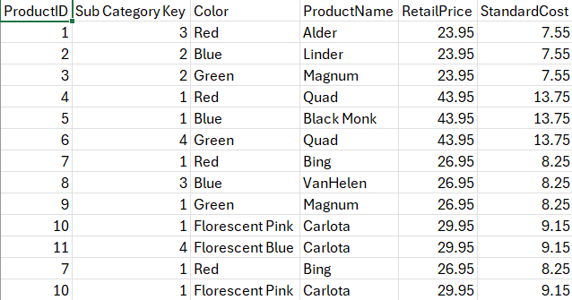

**3. DATA COLLECTION**

**Data Fields to Collect**

From the provided data, ensure the following fields are captured and processed:

**Mandatory Columns for Analysis:**

1. **SalesPrimaryKey**: Unique identifier for each transaction.
2. **ProductID**: Used to analyze product-specific performance.
3. **SalesRepID**: Enables tracking of sales performance by sales representatives.
4. **Location**: Important for analyzing sales by geography.
5. **Date**: Used to analyze sales trends over time.
6. **Units**: Number of units sold in each transaction.
7. **PercentOfStandardCost**: Helps in calculating profitability.
8. **RevenueDiscount**: Indicates the discount applied, which impacts total revenue.

**4. DATA VALIDATION**

**Validate Collected Data**

* Verify that derived metrics (e.g., Revenue, Profit) are accurate.
* Ensure all fields required for the dashboard (e.g., time period, locations, product) are consistent and complete.

**5. DATA CLEANING**

Handle Missing Data

Replace missing values or remove rows with essential missing data.

Correct Data Formats

Convert date fields to a uniform format (e.g., MM-DD-YYYY) and standardize text fields.

Filter Outliers

Remove unreasonable values in sales or profit fields.

Consolidate Data

Merge similar categories for streamlined analysis.

**6. TOOLS**

Power BI - Used for creating interactive dashboards and conducting in-depth data analysis.

Excel - Employed for preliminary data validation and cleaning.

**7. DASHBOARD**

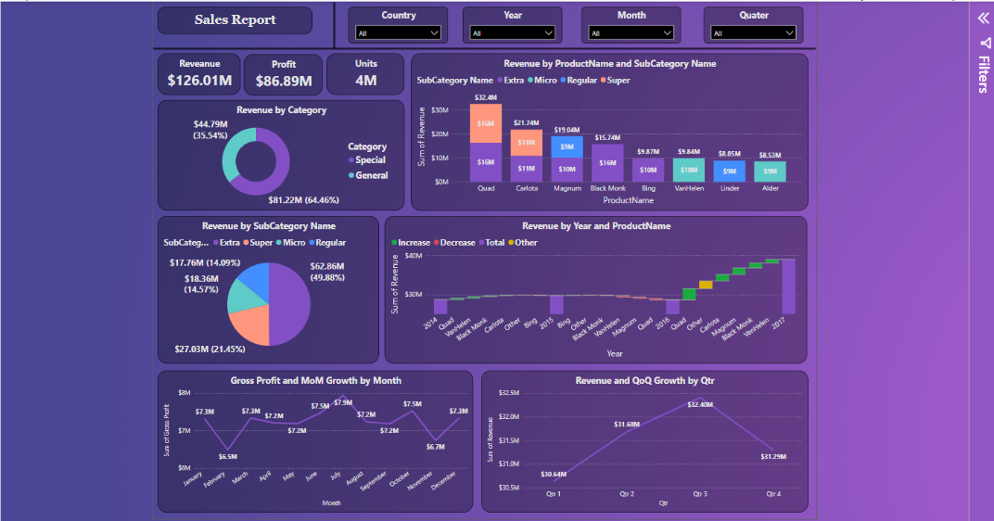

**Key Components of the Power BI Dashboard**

**1. High-Level KPIs (Top Section)**

* **Revenue**: Displays the total revenue ($126.01M).
* **Profit**: Shows total profit ($86.89M).
* **Units Sold**: Highlights the number of units sold (4M).
* **Filters**:
  + Country, Year, Month, and Quarter filters to dynamically slice the data.

**2. Revenue by Category (Donut Chart)**

* **Categories**:
  + "Special" contributing $44.79M (35.54%).
  + "General" contributing $81.22M (64.46%).
* **Purpose**:
  + Quickly understand the distribution of revenue between the two categories.

**3. Revenue by Subcategory Name (Pie Chart)**

* **Subcategories**:
  + "Extra," "Super," "Micro," and "Regular," with:
    - "Regular" being the largest contributor ($62.86M, 49.88%).
    - Others contributing smaller shares.
* **Purpose**:
  + Analyse revenue split within each main category.

**4. Revenue by ProductName and SubCategory Name (Bar Chart)**

* **Insights**:
  + Revenue contributions by each product grouped by subcategories (e.g., Quad, Carlota, Magnum).
  + Each bar segment color-coded by subcategories ("Extra," "Super," etc.).
* **Purpose**:
  + Identify top-performing products within each subcategory.

**5. Revenue by Year and ProductName (Stacked Line Chart)**

* **Insights**:
  + Shows revenue trends over the years for different products (Quad, Magnum, etc.).
  + Color-coded sections (increase, decrease, total, other) to track yearly performance.
* **Purpose**:
  + Identify yearly trends and performance changes for specific products.

**6. Gross Profit and MoM Growth by Month (Line Graph)**

* **Insights**:
  + Tracks monthly gross profit values (e.g., $7.3M, $7.2M).
  + Growth or decline in profit month-over-month (MoM).
* **Purpose**:
  + Highlight seasonality and pinpoint months with significant growth or decline.

**7. Revenue and QoQ Growth by Quarter (Line Graph)**

* **Insights**:
  + Quarterly revenue trends (e.g., $30.64M in Q1 to $32.40M in Q2).
  + Indicates quarter-over-quarter (QoQ) growth patterns.
* **Purpose**:
  + Monitor performance across quarters to guide sales and marketing strategies.

**8. Filters Panel (Right Sidebar)**

* **Dynamic Filters**:
  + Country, Year, Month, and Quarter filters enable users to drill down into specific regions, time periods, or scenarios.
* **Purpose**:
  + Provide interactivity and allow tailored analysis based on user needs.

**9. Visual Aesthetics**

* **Theme**:
  + Consistent purple theme enhances readability and visual appeal.
* **Chart Types**:
  + Diverse visuals (donut chart, pie chart, bar chart, line chart) to cater to varied data views.
* **Layout**:
  + Clear segmentation of KPIs and visual elements for easy navigation.

**8. STORYTELLING**

**1. Executive Summary**

"Our business has achieved a total revenue of $126.01M, with a profit of $86.89M, selling a total of 4M units. The primary contributors to revenue are the 'General' category and the 'Regular' subcategory, while significant growth opportunities exist across specific products and markets."

**2. Revenue Analysis**

* Category-Level Insights:
  + The "General" category generates 64.46% of the total revenue, amounting to $81.22M, showcasing its dominance.
  + The "Special" category, contributing $44.79M (35.54%), indicates potential for growth through enhanced marketing or new product introductions.
* Subcategory-Level Insights:
  + Within subcategories, "Regular" dominates with $62.86M (49.88%), followed by "Super" ($27.03M, 21.45%).
  + Subcategories "Extra" and "Micro" collectively account for nearly 29% of the revenue, representing areas for optimization or potential bundling strategies.

**3. Product Performance Insights**

* Top Performers:
  + Products such as Quad and Carlota are high revenue contributors, both at $16M.
  + These products are evenly distributed across multiple subcategories, suggesting they are strategic anchors in the portfolio.
* Underperformers:
  + Products like Alder and Linder, generating less than $10M, need deeper analysis to determine whether poor performance is due to low demand, marketing inefficiency, or pricing issues.

**4. Temporal Trends**

* Monthly Growth:
  + While monthly gross profit fluctuated, peaks occurred in May and July (over $7.5M each). Declines in March and June suggest opportunities to strengthen strategies during off-peak months.
* Quarterly Growth:
  + Revenue peaked at $32.40M in Q2 but slightly declined in Q3 ($31.68M) and Q4 ($31.25M).
  + Seasonal trends should be analyzed to leverage Q2 momentum and address QoQ stagnation.

**5. Geographic and Temporal Strategy**

* Regional Focus:
  + The sales data filtered by "Country" and "Location" should guide regional strategies. Markets like Germany (Frankfurt) and Denmark (Copenhagen) appear prominent in driving sales, whereas underperforming regions may require targeted campaigns.
* Time-Driven Interventions:
  + Focus on months with historical dips for promotional campaigns or product launches to even out seasonal fluctuations.

**6. Decision-Making Insights**

Short-Term Actions:

1. Enhance Marketing for Special Category: Focus campaigns to grow its contribution beyond 35.54%.
2. Upsell Regular Subcategory: Capitalize on its dominance by introducing premium variants or bundling with slower-moving categories.
3. Address Underperforming Products: Deep-dive into products like Alder and Linder to understand challenges and realign strategies.

Mid-Term Goals:

1. Seasonal Promotions: Design campaigns targeting dips in March and June to improve MoM performance.
2. Leverage High-Performing Quarters: Strengthen Q2 product launches and promotional strategies to maximize revenue.

Long-Term Strategy:

1. Diversify Product Portfolio: Innovate within the Special category to reduce reliance on the General category's dominance.
2. Expand Geographic Reach: Assess underperforming locations and focus on tailored strategies to drive growth in these regions.